El Chapo Is Down, But the Drugs Keep Coming

The capture of Mexico's biggest drug lord won't have a huge effect.
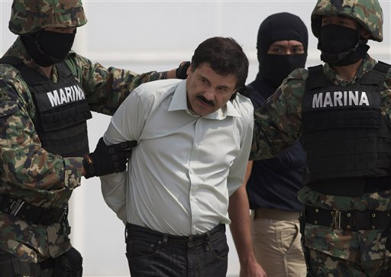
Joaquin "El Chapo" Guzman is escorted to a helicopter in handcuffs by Mexican navy marines at a navy hanger in Mexico City, Mexico.
By Duncan Wood and Cynthia J. Arnson Feb. 27, 2014 Leave a Comment SHARE
The events of the morning of Saturday February 22 have now passed into popular legend in Mexico. At 6:40 a.m., agents of the Mexican navy stormed into a beachfront condo in the town of Mazatlán in the state of Sinaloa, where they found the leader of the Sinaloa Cartel, Joaquín Guzmán Loera, alias El Chapo (or Shorty) asleep in bed with his wife and an AK-47. El Chapo’s two young children were asleep in a crib nearby. Across Mexico and around the world experts, analysts, and the general public reacted with shock at the news. Most people assumed that this near-mythical figure could not be captured, others that the government was not serious about bringing him to justice.
But Guzmán’s peaceful arrest, “without a single shot being fired” (in the words of the Mexican Attorney General Jesús Murillo Karam), is just the first event in a chain reaction that is now in motion. In addition to the questions surrounding his trial, incarceration, and possible extradition to the United States, many are asking what this means for the Sinaloa Cartel, for the business of moving drugs to the United States, for the standing of the Mexican government, and most importantly, for public security in Mexico.
To address the first point, we must say the capture of El Chapo will, in itself, not seriously challenge the Sinaloa Cartel’s operational capacity. The cartel is well-organized and has experienced lieutenants in place in all of the major areas where it conducts its business. The supposed successor to Guzmán, Ismael “El Mayo” Zambada, is a seasoned veteran of the cartel and has already been handling many of the duties of running business in the organization. The cartel has enough resilience to withstand the removal of its top figure; this is what makes it imperative for the Mexican government to carry out a sustained assault on the cartel if it intends to disrupt the organization’s activities.
The last three decades of the “drug war” in Colombia offer a glimpse into what Mexico might expect in the aftermath of Guzmán’s arrest. Following the capture or killing of senior leaders of Colombia’s Medellín, Cali and Norte del Valle cartels, their hierarchical, vertically-integrated structures were replaced by smaller criminal organizations with more fluid leadership. U.S. scholar Bruce Bagley has dubbed this process of fragmentation the “cockroach effect.” Not only does the proliferation of smaller organizations make them harder to combat, they continually morph and adapt in response to changes in the state policies to combat them.
As inventive, albeit illegal entrepreneurs, drug cartels constantly seek new market opportunities, both domestically and in new regions such as Africa. Unlike in Mexico, Colombia’s internal armed conflict has provided ample opportunities for trafficking organizations to ally with guerrillas or former paramilitary groups, increasing not only the lethality of the drug trade (and its consequences for the civilian population) but also transforming the nature of the insurgent groups themselves.
Understanding the internal structure of the Sinaloa cartel is thus crucial. Rather than simply a top-down, vertical hierarchy, Sinaloa is better visualized as a series of “nodes” around which activity is organized. Mexican scholar Victor Sánchez has recently demonstrated how an effective campaign against Sinaloa would have to remove multiple leaders before the flow of drugs is affected. Indeed, the general consensus in Mexico and the United States is now that El Chapo’s arrest will do little to stem the flow of drugs northward, with demand driving supply more than any other factor.
The capture is of significant importance, however, in establishing the credibility of Mexican President Enrique Peña Nieto’s security and organized crime strategy, which has been heavily criticized for focusing too much on violence reduction and crime prevention rather than taking on the criminals themselves. This highest profile arrest gives the president and his security team ammunition to reject such attacks and the inspiration to continue the struggle.
However, we should not expect a major change in the short term. Just as some of the security advances in Colombia in the 2000s pushed trafficking routes into Mexico, gains in one arena produce setbacks in others. The consequences may be unintended, but they are not unpredictable. As long as demand for drugs remains robust and profits sky-high, we will continue to chase, if not this Chapo, then others who arise to take his place.

