Homework: Wednesday 9/17
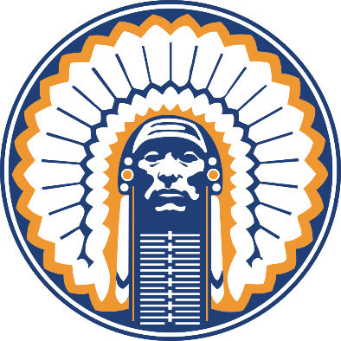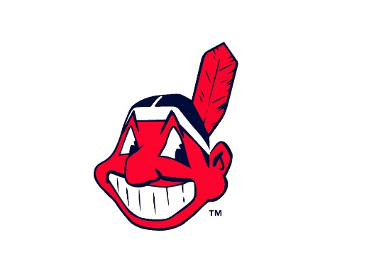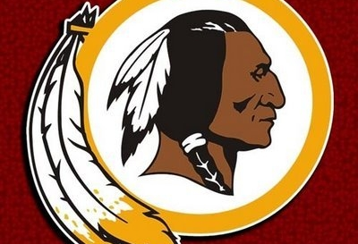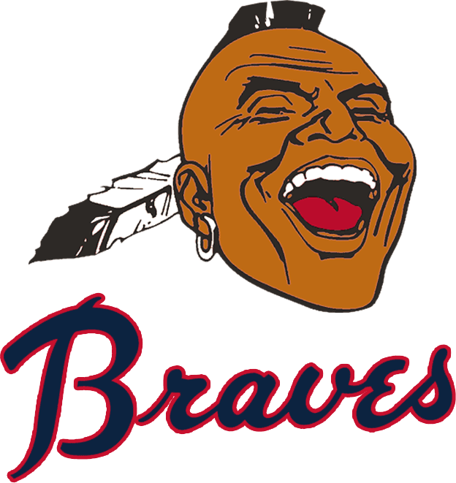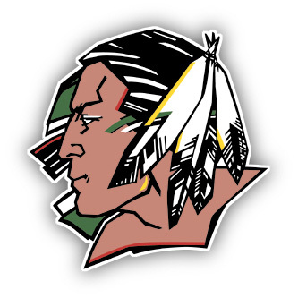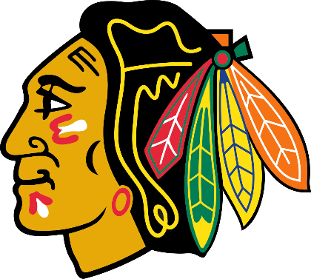

Research 3 different sports teams with Native American names or logos. You can choose from NHL, MLB, NFL or NCAA.
1) List the school/organization and the name of the mascot. Has there been any recent controversy behind the team name or logo? Was the issue resolved? Mascot or team name changed?
The next three questions should be answered in the form of short paragraphs (5-6 sentences each) and draw from your research.
2) Why would the name or logo be offensive to Native Americans in general or specific tribes?
3) Do you believe that the names should be changed completely, or should the teams just alter their logos to become less offensive to Native Americans? Explain using at least one clear example from your research.

